<https://www.tutorialspoint.com/tableau/tableau_get_started.htm>

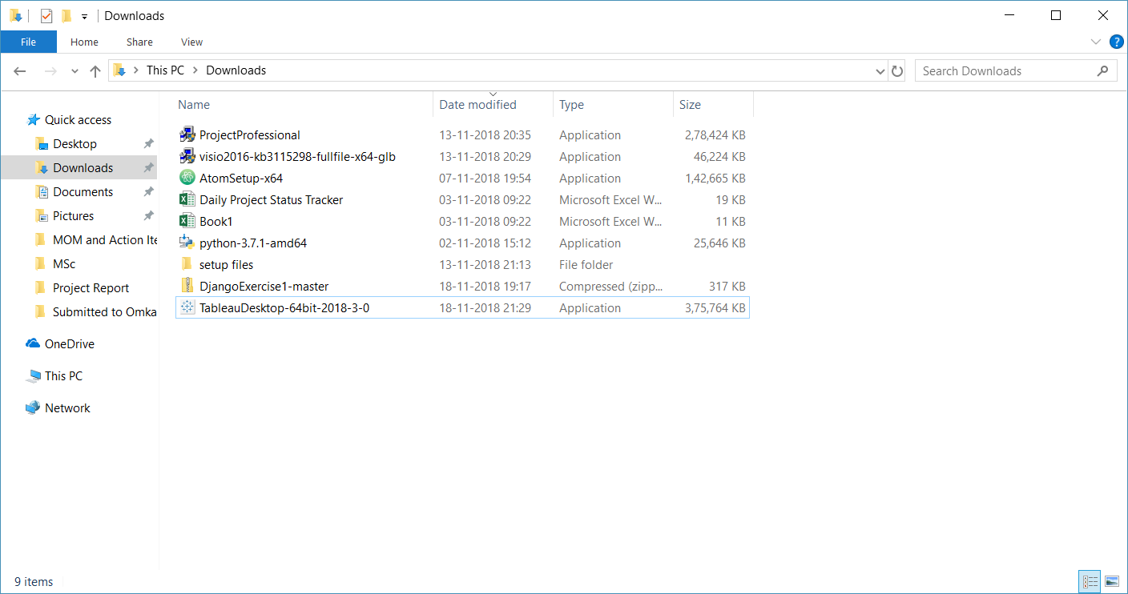

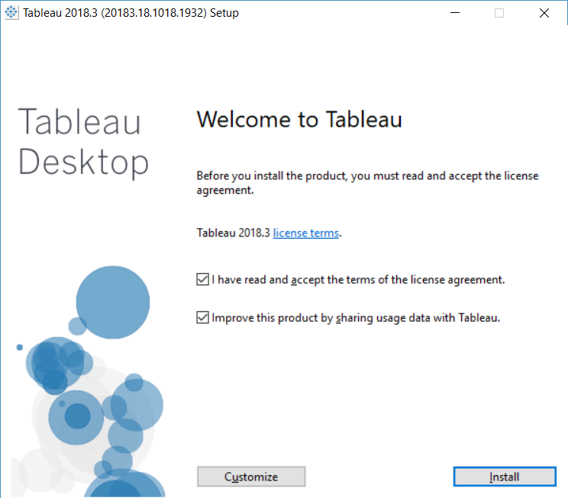

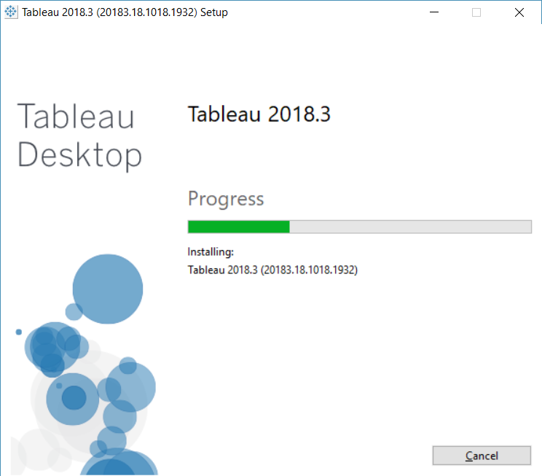

To a file – Microsoft Excel.

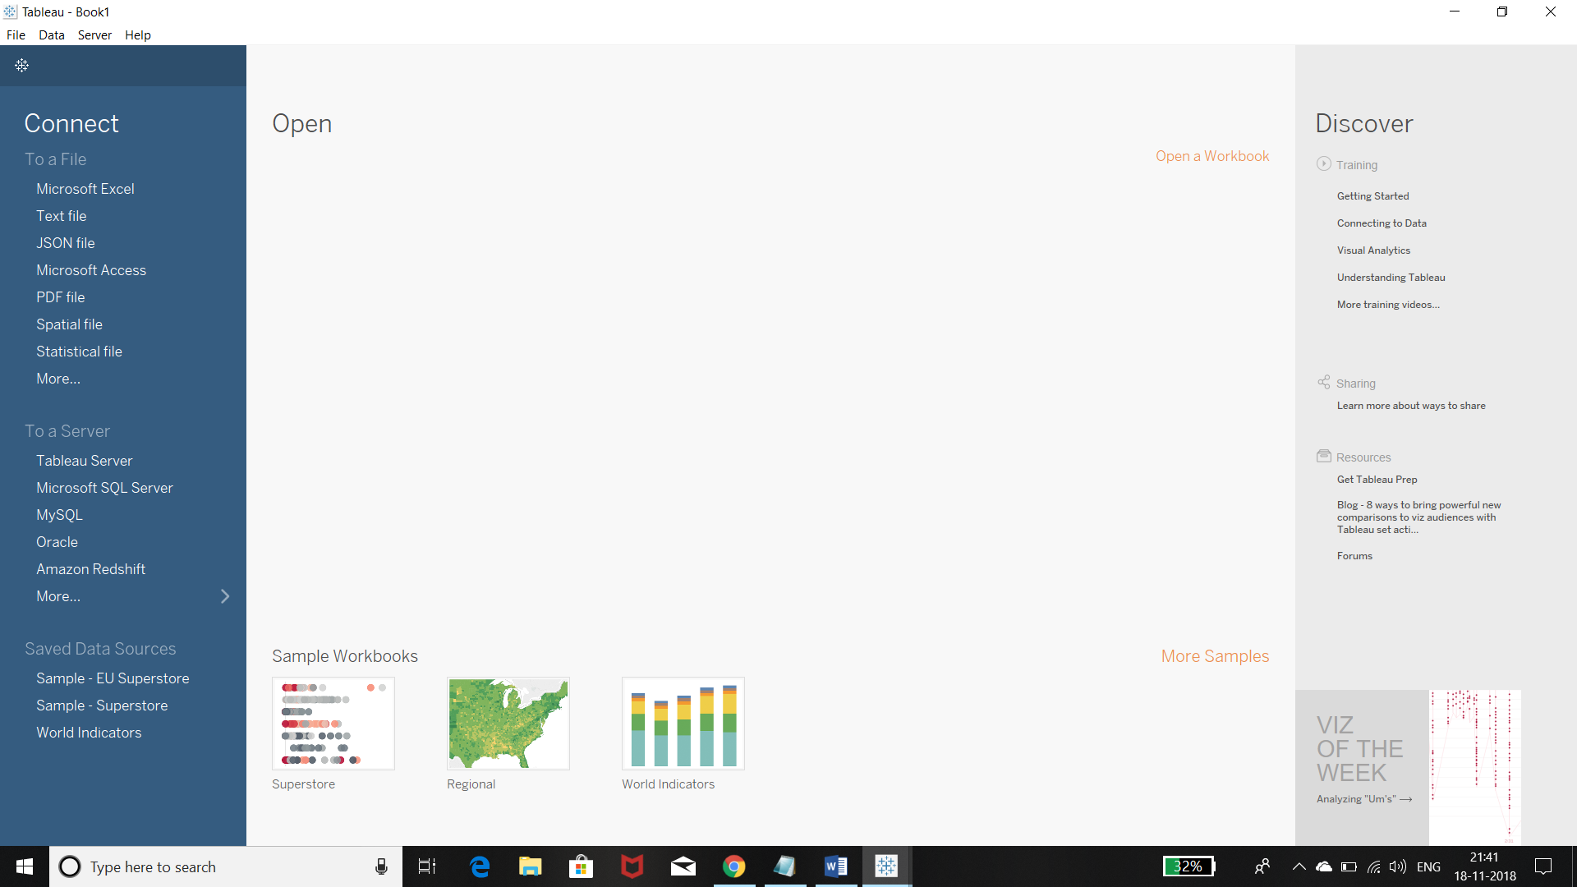

Browse Sample – Superstore.

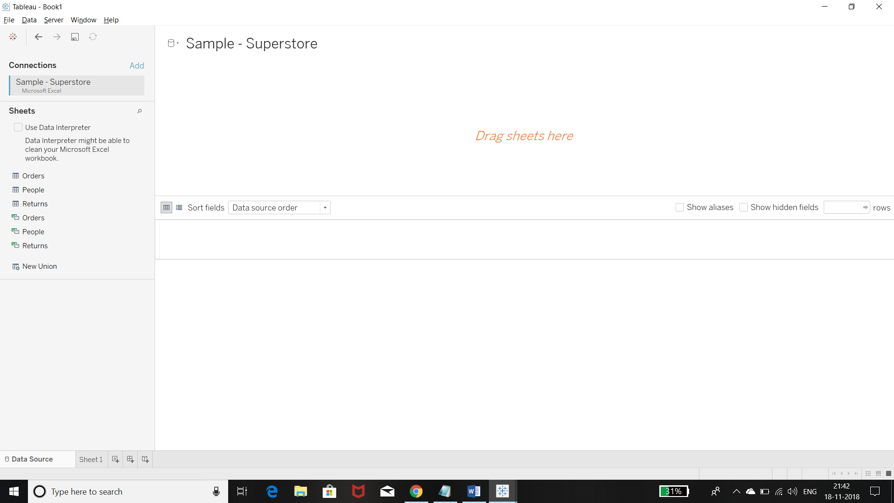

Drag and drop the “Orders” sheet.

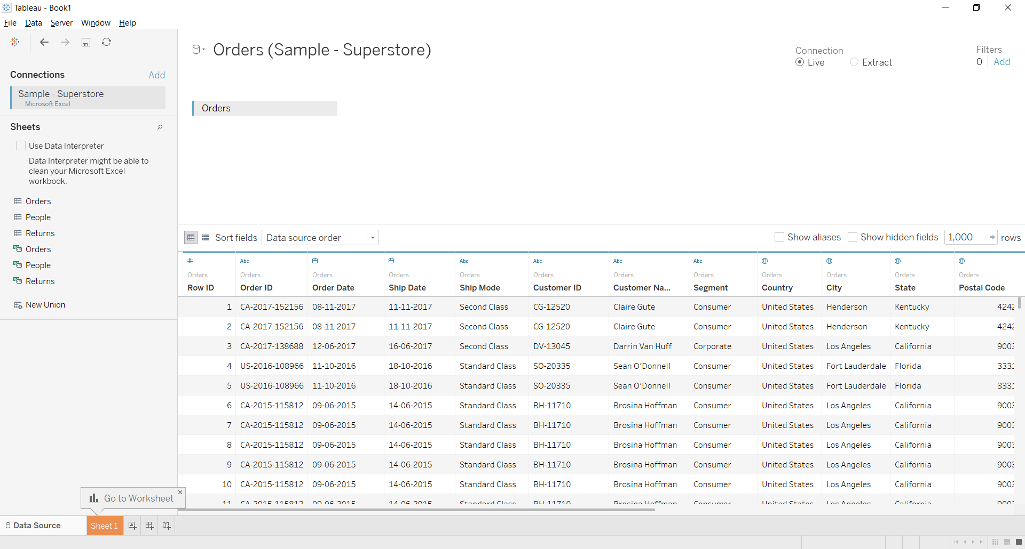

Click the sheet tab to go to the new worksheet and begin your analysis.

<https://onlinehelp.tableau.com/current/pro/desktop/en-us/getstarted_buildmanual_ex1basic.htm>

File – New : Opens a new blank workbook.

<https://www.tableau.com/learn/training?build=20183.18.1018.1932&edition=pro&lang=en-us&platform=windows&version=2018.3>